**Pizza Sales Analysis SQL-Report**

**KPI’s Requirement**

1. Total Revenue



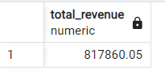

1. Average Order Value:



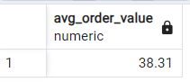

1. Total Pizza Sold:



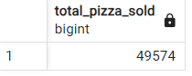

1. Total Order:



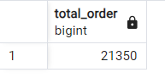

1. Average Pizza per Order:



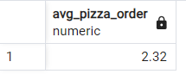

**Day wise Trend for Orders:**

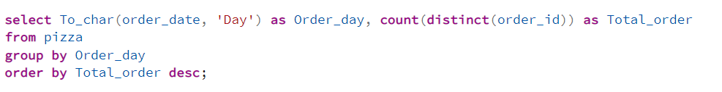

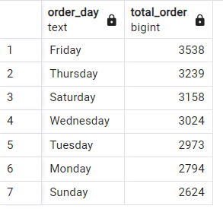

**Month wise Trend for Orders:**

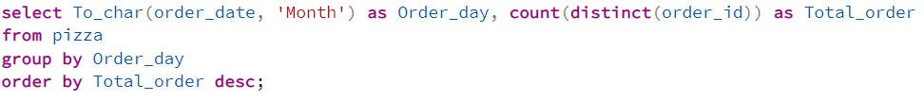

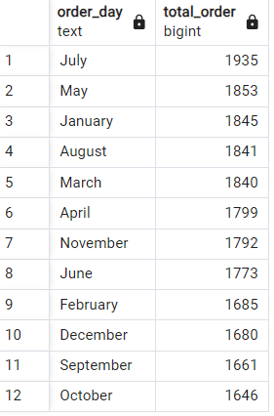

**Percentage of Sale by Category:**

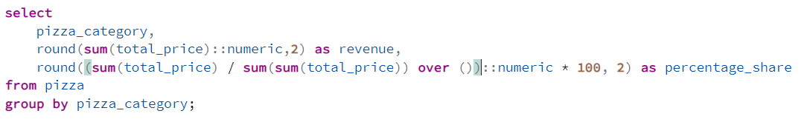

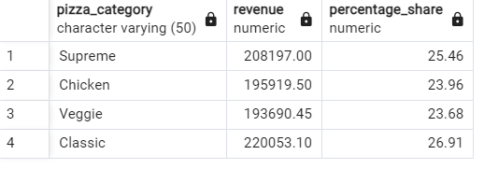

**Percentage of Sale by Pizza Size:**

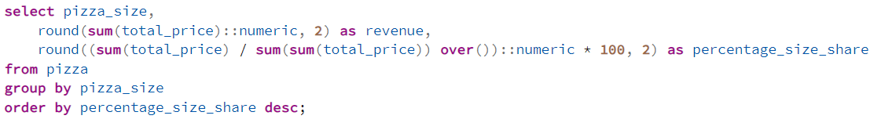

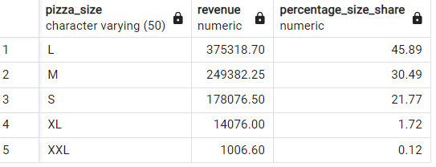

**Total Pizza sold by Category:**

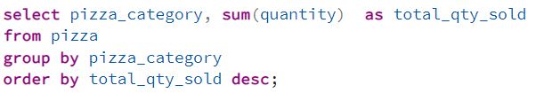

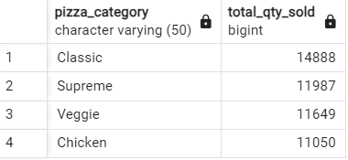

**Top 5 Pizza by Revenue:**

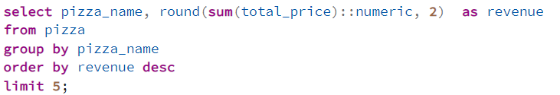

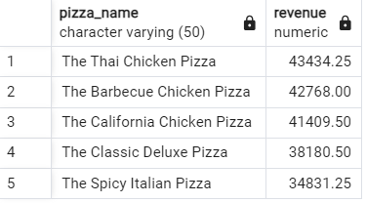

**Bottom 5 Pizza by Revenue:**

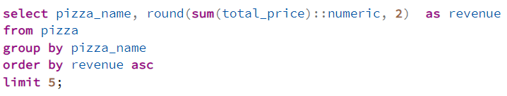

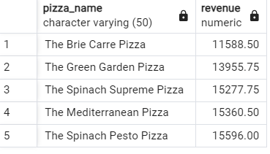

**Top 5 Pizza by Quantity:**

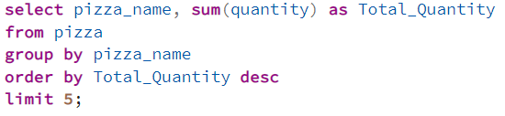

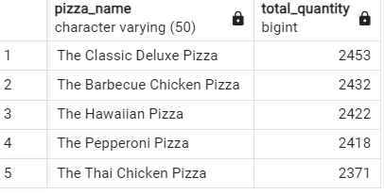

**Bottom 5 Pizza by Category:**

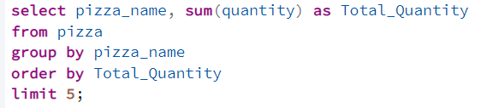

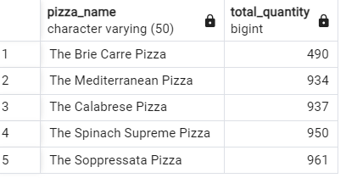

**Top 5 Pizza by Total Order:**

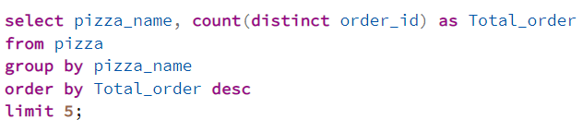

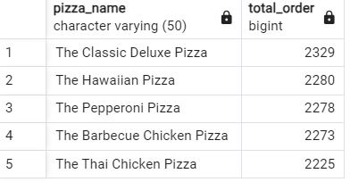

**Bottom 5 Pizza by Total Order:**

